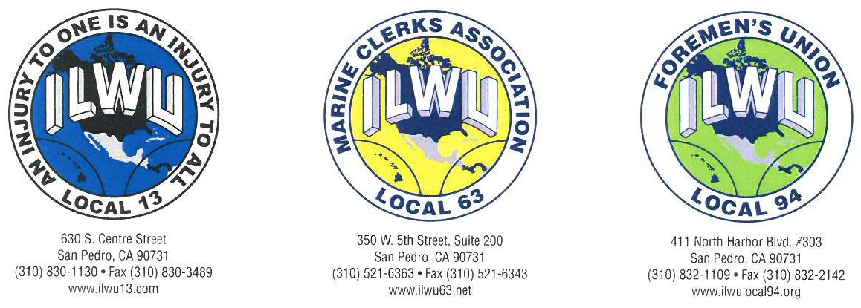

February 2, 2017

ATTENTION EVERYONE WHO
MAILED IN A
PUBLIC CARD

In regards to the January 2017 Longshore Opportunity process in the Ports of Los Angeles/Long Beach, it has come to the Officers’ attention that many Public post cards were returned to the senders by the U.S. Post Office in error.

As noted in the newspaper advertisements concerning this Longshore Opportunity process, any disputes or claims about any aspect of this Casual processing program must be in writing and received by the Joint Port Labor Relations Committee (“JPLRC”) within ten (10) calendar* days (no extensions) of the source of the complaint* at the below mailing address. Decisions of the JPLRC are final and binding.

Mailing Address for Disputes or Claims:
JPLRC – LA/LB Casual Processing Grievance
P.O. Box 21618
Long Beach, CA 90801
Source of complaint example:
1. The day you discover your card got returned.
Please note - this does not apply if your card is not a part of the draw.

Fraternally,
Bobby Olvera, Jr. Paul Trani Daniel Miranda
President President President
ILWU Local 13 ILWU Local 63 ILWU Local 94

